Bernardo Fitzmaurice Acevedo 105297603 Class code: COS30031

Start date: 02/08/2024

Game Engine Analysis

We all know what a game engine is, so I will not waste that much time on an

introduction. On this paper I’ll analyze the Godot engine, its features, how it works, the games that were made with Godot, etc.

Godot has some main features that allow the users to work much easier than other game engines. These features allow the user to use building blocks (better called “nodes”) to create scenes, and to add code scripts to each scene. Godot uses the language GDScript, a language inspired by Python, so it’s easier to pick up for beginners, but it also allows users to use C# while still having the benefit from using

GDScript. It is also used to create projects in both 2D and 3D. For the 3D games you’re allowed to make your own scenes directly from the engine; and for 2D games the engine lets you create the game’s map directly from a map editor, either as a procedural generator, or a more meticulously handmade map. Lastly, since Godot is an open- source program, it allows the users to modify the engine to what they need.

Users can download Godot from 3 places, directly from the internet, from steam or from the epic store. Of course, each of them has their own advantages and disadvantages. In the case of downloading Godot directly from the internet, every time an upgrade is launched, you’ll need to download the update manually, but if the update came with a

bug, you could wait for the developers to patch it before updating it. In the case of steam, the update is done automatically, and if there’s a bug you can revert the program to a previous update and wait for it to be patched before going back to the most recent update. Lastly, the Epic Store is the same as Steam, but, unlike steam, you cannot revert the program to its previous version, so if there’s a bug, you are stuck with it until it’s fixed.

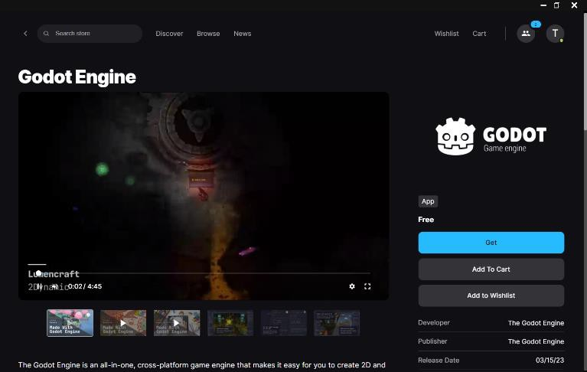 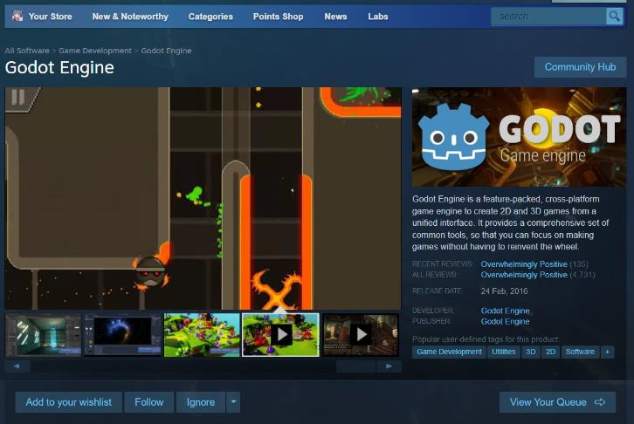

Godot in Epic Store. Godot in Steam.

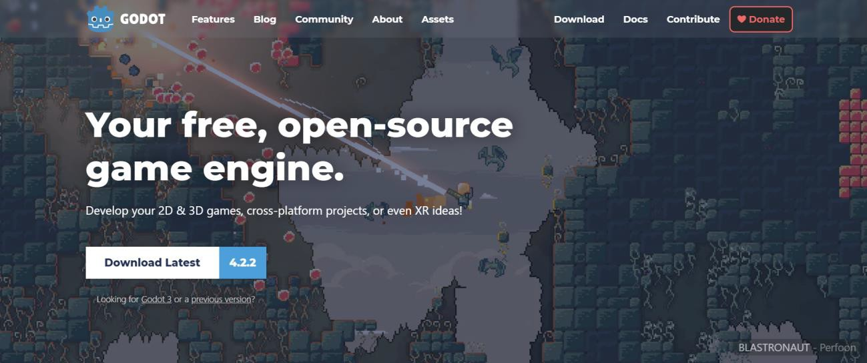

Godot in browser.

Of course, like any game engine, Godot many games have been made using Godot, some examples are:

1. Sonic Colors Ultimate.
2. Project Kat – Paper Lily prologue.
3. Paper Lily.
4. HaachamaWare.
5. Blackout.

Those are the only 5 games that came to mind, but there are many more games made with Godot. At the end I will put a link that shows many more. I also want to say that Sonic colors use 3 game engines, and Godot is one of them.

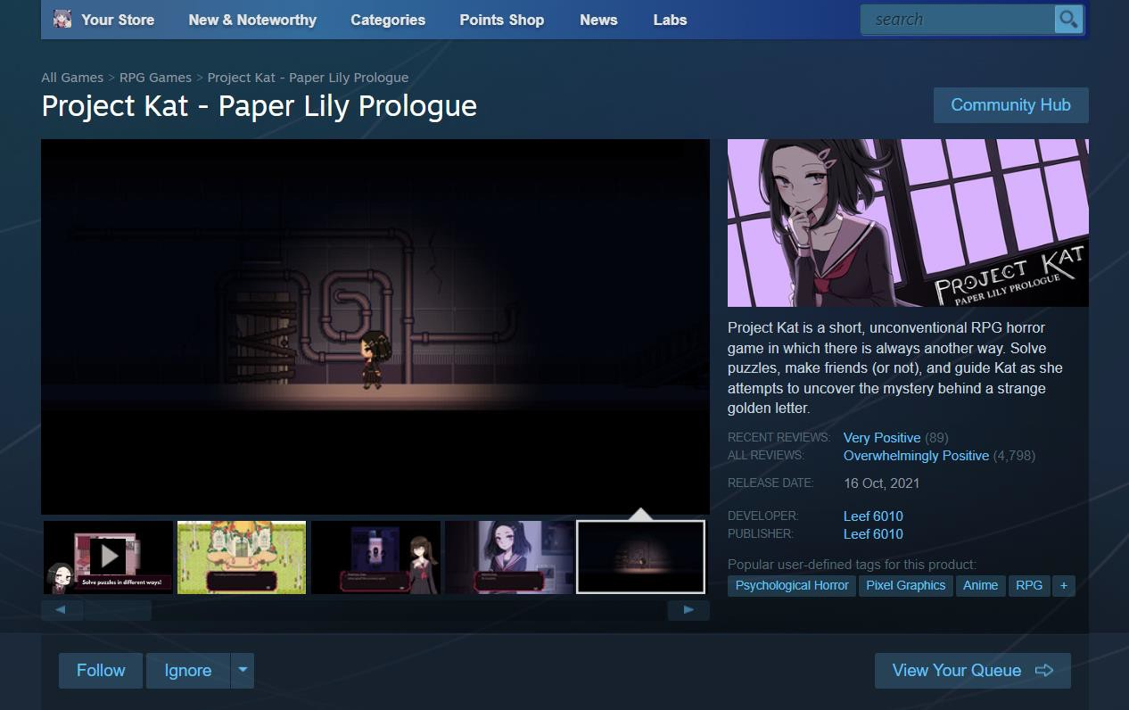

Project Kat steam page.

Now that the semester is almost finished, I am going to update this document and answer the next two questions:

*What other features would you assess when selecting a game engine that you did not include in your initial report?*

*How does the Game Engine you selected fare when analyzing these additional features?*

To be honest, the extra features that I didn’t mention before that I would definitely assess now are documentation, Engine’s community, libraries available and language available.

To start with, Godot has many documentations available, either provided by the own Godot team or by regular developers. This is thanks to all the people that are part of the Godot community and that are very passionate about game development, finding and fixing flaws within the engine. Something to be intuited by my previous state is that the Godot community is big and very passionate, helping most of the users with their errors and with the bugs that are found.

And about the libraries and the language, Godot allows not only the native libraries downloadable from the engine, but also allows users to add third party libraries if they wish and if useful to them. And the languages are multiple, allowing users to use the one they see that fits the most with their project. But users mainly use C++ and C#.

If we take all the previous said, I consider that Godot fare in a very positive light, since it allows flexibility to the users in terms of libraries and languages. And it definitely shines because of the documentation, since there’s a lot and it’s always growing. But something Godot is lagging at the moment is the community, since many problems arose in the community and now it’s divided in two, the Godot community and the Redot community.

To finish this report, I would still recommend Godot as an engine, but I would also recommend any user to learn another engine as a backup, just in case Godot gets worse because of the community, which I see unlikely to happen, but one never is to sure about something.

**References:**

Engine, G. (n.d.). *Features - Godot Engine*. Godot Engine. <https://godotengine.org/features/>

Engine, G. (n.d.-a). *Download for Windows - Godot Engine*. Godot Engine. <https://godotengine.org/download/windows/>

*Website vs Steam godot - Godot Forums*. (n.d.). [https://godotforums.org/d/37376-](https://godotforums.org/d/37376-website-vs-steam-godot) [website-vs-steam-godot](https://godotforums.org/d/37376-website-vs-steam-godot)

Wiki, C. T. C. M. (n.d.). *Cooking Mama 2: Dinner with Friends*. Cooking Mama Wiki. https://cookingmama.fandom.com/wiki/Cooking_Mama_2:_Dinner_with_Friends

Zone, C. T. S. W. (n.d.). *Sonic colors: Ultimate*. Sonic Wiki Zone. https://sonic.fandom.com/wiki/Sonic_Colors:_Ultimate

*Top rated games made with Godot*. (n.d.). itch.io. [https://itch.io/games/top-rated/made-](https://itch.io/games/top-rated/made-with-godot) [with-godot](https://itch.io/games/top-rated/made-with-godot)